

School Funding Formula

for 2024/25

Consultation

Consultation between Westmorland & Furness Schools Forum and

Maintained Schools & Academies within Westmorland & Furness

Consultation Commences: Wednesday 27 September 2023

Deadline for responding to the [consultation](https://consult.westmorlandandfurness.gov.uk/education/school-funding-formula-consultation): Wednesday 18 October 2023

**Introduction**

**National Funding Formula**

1. A national funding formula (NFF) was introduced for schools from 2018/19 and as in previous years, in 2024/25 local authorities will continue to decide, following consultation with their schools and Schools Forum, whether this formula is applied or a locally determined formula is used.
2. This document comprises a consultation with all Westmorland & Furness mainstream schools/academies and Schools Forum to seek views on the proposed changes to the schools funding formula in 2024/25. The consultation also considers some of the continuing challenges around high needs budget.
3. All schools are encouraged to respond to this consultation using the [online survey](https://consult.westmorlandandfurness.gov.uk/education/school-funding-formula-consultation). The deadline for responding to the consultation is 18 October 2023. The outcome of the consultation will be reported to Schools Forum at their next meeting on 1 November who will, after taking into consideration the consultation results, make a recommendation to Cabinet members who will decide on the final shape of the school funding formula for 2024/25 in December 2023.
4. Schools can find further detailed information on the national funding formula at: [National funding formula for schools and high needs - GOV.UK (www.gov.uk)](https://www.gov.uk/government/publications/national-funding-formula-for-schools-and-high-needs)

**Shape of the National Funding Formula in 2024/25**

1. In July 2023 the government announced that in 2024/25 the schools and high needs block funding would rise by £1.8bn nationally compared to 2023/24. Of this, £440m is being directed to the High Needs Block to support children and young people with special educational needs.
2. Local authorities will continue to have flexibility to set a local school funding formula in 2024/25 however the government continues to be committed to moving towards a ‘hard’ NFF whereby individual school budgets will be set directly by the ESFA rather than independently through a locally agreed funding formula. In 2023/24 local authorities were required to bring their own formulae at least 10% closer to the direct NFF. Local authorities whose factor values were within +/-2.5% of the respective NFF values in 2023/24 are deemed to be mirroring the NFF and will only be allowed to set their 2024/25 local factor values between +/-2.5% of the NFF. This restriction is being applied again in 2024/25.
3. Changes in the 2024/25 NFF include the roll in of the Mainstream Schools Additional Grant (MSAG) of which £4,510 has been added to each school’s lump sum factor and the remainder has been allocated on a per pupil basis as follows:

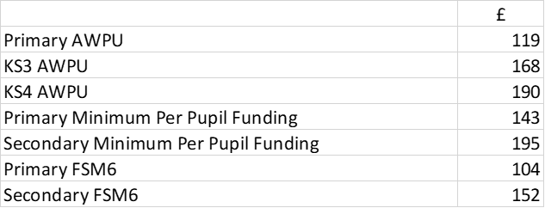

1. On top of these increases, the basic per pupil funding factor, additional needs factors and the school lump sum have increased by 2.4%. The free school meals (FSM) factor will increase by 1.6%. The minimum per pupil funding levels (MPL) have been set at £4,655 per primary and £6.050 pe secondary pupil.
2. A new split sites factor which targets extra funding to schools which operate across more than once site has been introduced into the NFF which must be used by local authorities in their local school funding formula. It comprises of a lump sum of £54,300 and for those schools whose sites are separated by more than 100 meters receive distance funding on a sliding scale up to a maximum of £27,100 for sites which are at least 500 metres away from the main site.
3. The settlement also allows for an increase to the funding floor so that all schools and academies will attract at least 0.5% per pupil gain against their 2023/24 per pupil baselines which have been adjusted to include the MSAG. Local authorities will continue to be allowed to set a minimum funding guarantee (MFG) in local formulae, which must be between +0% and +0.5%.
4. As in previous years, local authorities are allowed, with the agreement of their Schools Forum, to transfer up to 0.5% of the School Block funding to support the High Needs Block budget.
5. The below table shows a comparison between the formula factors applied in Westmorland & Furness in 2023/24 and the NFF in 2024/25:

|  |  |  |  |
| --- | --- | --- | --- |
|  | **2023-24** | **2024-25** | **Increase** |
|  | **Unit Value** | **Unit Value** | **%** |
| **Basic per Pupil Funding** |  |  |  |
| Primary AWPU | £3,387 | £3,597 | 6.20% |
| KS3 AWPU | £4,775 | £5,072 | 6.22% |
| KS4 AWPU | £5,381 | £5,717 | 6.24% |
| Primary Minimum Per Pupil Funding | £4,405 | £4,655 | 5.68% |
| Secondary Minimum Per Pupil Funding | £5,715 | £6,050 | 5.86% |
| **Deprivation** |  |  |  |
| Primary FSM | £480 | £490 | 2.08% |
| Secondary FSM | £480 | £490 | 2.08% |
| Primary FSM6 | £705 | £830 | 17.73% |
| Secondary FSM6 | £1,030 | £1,210 | 17.48% |
| Primary IDACI A | £670 | £685 | 2.24% |
| Primary IDACI B | £510 | £520 | 1.96% |
| Primary IDACI C | £480 | £490 | 2.08% |
| Primary IDACI D | £440 | £450 | 2.27% |
| Primary IDACI E | £280 | £285 | 1.79% |
| Primary IDACI F | £230 | £235 | 2.17% |
| Secondary IDACI A | £930 | £950 | 2.15% |
| Secondary IDACI B | £730 | £750 | 2.74% |
| Secondary IDACI C | £680 | £695 | 2.21% |
| Secondary IDACI D | £620 | £635 | 2.42% |
| Secondary IDACI E | £445 | £455 | 2.25% |
| Secondary IDACI F | £335 | £345 | 2.99% |
| **Low Prior Attainment** |  |  |  |
| Primary LPA | £1,155 | £1,185 | 2.60% |
| Secondary LPA | £1,750 | £1,790 | 2.29% |
| **English as an Additional Language** |  |  |  |
| Primary EAL | £580 | £595 | 2.59% |
| Secondary EAL | £1,565 | £1,605 | 2.56% |
| **Mobility** |  |  |  |
| Primary mobility | £945 | £970 | 2.65% |
| Secondary mobility | £1,360 | £1,395 | 2.57% |
| **School Led Funding** |  |  |  |
| Lump Sum | £128,000 | £135,700 | 6.02% |
| Primary Sparsity (Up to a maximum of) | £56,300 | £57,700 | 2.49% |
| Secondary Sparsity (Up to a maximum of) | £81,900 | £83,900 | 2.44% |
| New Split Site Lump Sum | n/a | £54,300 |  |
| New Split Site Distance (Up to a maximum of) | n/a | £27,100 |  |
| Rates & Rents | Actual cost | Actual cost |  |

**Westmorland & Furness Schools Funding Formula in 2023/24**

1. Following consultation with schools and Cumbria Schools Forum the school budget shares were calculated using the NFF in 2023/24 and it was recommended by Schools Forum and agreed by Cabinet members that if there was a leftover balance remaining after allocating the school budgets on this basis that up to 0.5% would transfer to the High Needs Block. When the DfE confirmed the final Schools Block funding for 2023/24 in December 2022, the school funding formula was calculated on the basis agreed and there was an affordability gap of £0.179m resulting in a small reduction in the basic per pupil funding factor compared to the NFF of -0.21%. As there was no balance remaining in the Schools Block after applying the funding formula on this basis there was no transfer to the High Needs Block to support the budget pressures in 2023/24.

**Westmorland & Furness Proposed School Funding Formula 2024/25**

1. The DfE have published notional 2023/24 budgets for each school based on the NFF using 2023/24 pupil data and characteristics. The notional budgets are available at: [National funding formula tables for schools and high needs: 2024 to 2025 - GOV.UK (www.gov.uk)](https://www.gov.uk/government/publications/national-funding-formula-tables-for-schools-and-high-needs-2024-to-2025).
2. The notional budgets, which are based on October 2022 pupil numbers and pupil characteristics, are then used by the ESFA to determine the actual primary and secondary per pupil funding units used to calculate the local authority level allocations for 2024/25. The ESFA calculate these units of funding by separately dividing each local authority’s total primary and secondary funding through the NFF by its total primary and secondary pupil numbers. These units of funding form the core NFF funding and together with funding for Premises which is based on 2023/24 costs and Growth funding which also now includes funding for falling rolls comprise the total Schools Block allocation for 2024/25. The DfE have published the provisional Schools Block allocation for Westmorland & Furness which is compared to 2023/24 in the table below:



1. The actual 2024/25 school funding formula allocations will be based on October 2023 pupil numbers and pupil characteristics. The Westmorland & Furness Schools Forum recommends that the NFF is used as the basis for allocating funding to schools in 2024/25 and that if, after applying the formula on this basis and taking into account any budget required to support growth needs there is shortfall or balance remaining in the Schools Block funding then it is proposed that the following principles are applied:

* if there is shortfall reduce the basic per pupil funding factor values in the formula;
* if there is a remaining balance transfer up to 0.5% to the HN Block and allocate any leftover balance after that, if available, to schools by increasing basic per pupil funding factor values in the formula.

1. This would continue be the most prudent method of allocating the school budget shares in 2024/25 given that it is known that the government are moving forward with their plans to transition to a ‘hard’ formula in future years and that the majority of local authorities have either adopted the NFF or moved their own local formulae closer towards the NFF in preparation for this change. It will also provide schools with the full funding due to them under the NFF, subject to affordability.
2. A shortfall or balance remaining in the Schools Block funding can arise after allocating the funding to schools using the NFF due to the way local authorities are funded as detailed in paragraph 15. The actual primary and secondary units of funding at local authority level are based on October 2022 pupil data and changes in pupil characteristics such as eligibility for FSM or changes in attainment levels are not reflected in the primary and secondary units of funding used to allocate the core NFF funding to local authorities in 2024/25. It is anticipated that the number of children eligible for FSM will have increased between the October 2022 and 2023 census dates and therefore this could mean that applying the NFF in full will be unaffordable in 2024/25 as it was in 2023/24.
3. The Premises factor at local authority level, which is based on the previous year’s actual spend in their 2023/24 school funding formula will also have an impact on affordability as 2024/25 school funding formula will be based on estimated premises costs for 2024/25.
4. The local authority level Growth Fund which, from 2024/25 also includes funding for falling rolls, is not ring-fenced and local authorities can decide on the level of growth/falling rolls budgets needed locally in consultation with Schools Forum. Historically, since the introduction of the NFF Cumbria has had Growth fund to support schools who have exceeded their PAN on the request of the local authority and this can also impact on the level of funding available to allocate through the school funding formula.
5. The alternative option would be not to transfer any leftover Schools Block funding to the HN Block but to allocate it, after applying the NFF, to schools through the school funding formula by ‘topping up’ the AWPU factor values but due to the new restrictions being imposed by government from 2023/24 any increases would be limited to +2.5%. However, it is not yet known how much funding will be available (if any) after applying the NFF as the final Schools Block funding, which will be based on the October 2023 census data, will not be made available until December 2023. Therefore, it is not possible to model the impact of this on individual school budgets with any degree of accuracy.
6. If any leftover Schools Block funding were to be allocated to schools through the schools funding formula by increasing the AWPU factor values above the level of the NFF values, not all schools would see an increase in their budget shares. This is because some schools receive protection through the MPL and MFG factors and therefore, unless the increase in APWU takes them over these levels of protection then they will see no change to their budget shares.
7. There is also a risk that, due to the proposal requiring local authorities to move their local formula closer to the NFF from 2024/25 onwards, ‘topping up’ the NFF factor values by allocating additional funding through the formula would create turbulence for some schools, although they would receive protection against year-on-year reductions through the MFG.
8. Appendix 1 to this consultation presents a comparison between the actual Westmorland & Furness school funding formula in 2023/24 against the proposed school funding formula for 2024/25. This mirrors the national funding formula as applied by the DfE and includes the mandatory MPL of £4,655 per primary and £6,055 per secondary pupil and a MFG of +0.5% per pupil increase against 2023/24 baselines.
9. The school level allocations do not exactly replicate the notional school budget shares as published by the DfE for all schools because the DfE have used the notional NFF baselines for 2023/24 to calculate the MFG for 2024/25 rather than the actual baselines for 2023/24 as submitted to the DfE through the Authority Proforma Tool (APT).
10. It is also important to note that the notional budgets published by the DfE are not reflective of actual amounts receivable by schools in 2024/25 as the local authority continues to have flexibility to set a locally agreed funding formula through consultation with schools and Schools Forum and it must also ensure that the final formula is affordable and does not exceed the School Block funding available.
11. The proposed school funding formula for 2024/25 will impact on maintained schools with effect from 1 April 2024 and for academies from 1 September 2024.
12. To enable a like for like comparison the illustrative 2024/25 school funding formula has been based on the same pupil numbers and pupil characteristic data as that used to calculate the actual 2023/24 school funding formula. The 2023/24 baseline school budget shares used to calculate the MFG have been adjusted to include the MSAG.
13. Final allocations for 2024/25 will be based on the December 2023 dataset which will use October 2023 census pupil data.
14. It should be noted that the actual school funding formula figures for 2023/24 and illustrative school funding formula figures for 2024/25 in Appendix 1 are shown before de-delegation has been deducted from maintained schools budgets and include premises factors (rates and rents) which have been based on 2023/24 actual levels for both maintained and academy schools as applied in the APT submitted to the DfE.

**Consultation Question 1:**

**Do you agree with your Schools Forum recommendation that the National Funding Formula continues to be used to allocate funding to schools in 2024/25?**

1. As recommended by your Schools Forum, if applying the national funding formula creates an affordability gap within the School Block it is proposed that the basic per pupil funding factor values are reduced down proportionately to a level that it affordable. It should be noted that if this situation were to arise not all schools would see a reduction in their budget shares. This is because some schools receive protection funding through the MPL and MFG factors and are protected against loses through these factors.

**Consultation Question 2:**

**Do you agree with your Schools Forum recommendation that if there is a shortfall in Schools Block funding after applying the National Funding Formula that this is managed by reducing the basic per pupil funding factor values in the formula?**

**High Needs Funding**

1. As previously published in last year’s school funding formula consultation, schools will be aware, like many other local authorities, that Westmorland & Furness is experiencing significant budget challenges in relation to funding high needs provision.
2. The DfE requires all local authorities with a cumulative Dedicated Schools Grant (DSG) deficit to set out their plans to bring the reserves back to a balanced position. Following disaggregation the opening balance on the DSG reserves as at 1 April 2023 for Westmorland & Furness was a net deficit of £8.741m. The main pressure on the DSG reserves was the deficit on the HN Block of £12.017m this was offset by a surplus on other DSG blocks of (£3.276m). This this figure does not include school balances which are reported on separately.
3. The deficit on the High Needs budget continues to relate to specific pressures relating to the growth in demand for Education Health Care Plans (EHCPs) for pupils with SEN which is directly linked to the SEND reforms of 2014, since which there has been a steep increase in the cumulative numbers of pupils with EHCPs over the last 7 years, which reflects the national picture with many other local authorities also experiencing significant pressure against the High Needs budget.
4. The benchmarking chart below shows that Westmorland & Furness’ percentage of pupils with EHCPs is higher compared to the national and Cumbria statistical neighbours rates although the rate of increase for Cumbria overall is largely matched by the rate of increase both nationally and against the Cumbria statistical neighbours.

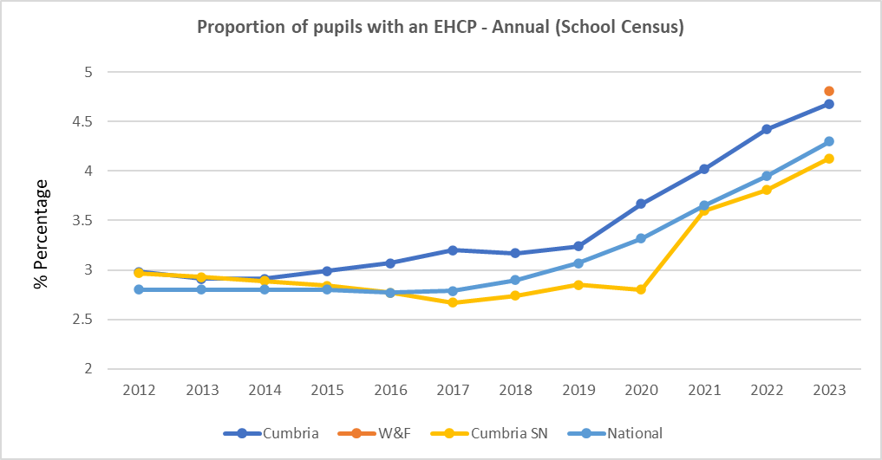

1. In July 2023 the DfE announced the provisional HN block funding allocation for 2024/25. This included a minimum increase per head of 2 to 18 year old population of 3% capped at 5% however this protection only applies to specific factors in the funding formula. For Westmorland & Furness the overall provisional increase in HN Block funding is estimated to be £0.675m (2.43% increase) compared to 2023/24 subject to changes in pupil numbers and other later adjustments.
2. Regular budget monitoring reports on the High Needs Block budget and progress against the deficit recovery plan are discussed at Schools Forum meetings. The minutes and reports are available to download from the [Schools Forum](https://legacy.westmorlandandfurness.gov.uk/childrensservices/schoolsandlearning/schools/schoolsforum/default.asp) page on the Westmorland & Furness website. However, despite the impact of a number of invest to save initiatives including early intervention initiatives, school based alternative provision programmes and expansion of special school places all of which over time are expected to reduce reliance on expensive independent providers and improve outcomes for children and young people with SEND, there is still a significant gap between funding available and forecast expenditure in 2023/24.
3. Westmorland & Furness is being supported by the DfE’s Delivering Better Value for SEND programme the aim of which is to a achieve a balanced in-year position on the High Needs Block and has successfully bid and received a £1m grant to support its improvement plans the outcomes of which will be incorporated into a new Westmorland & Furness DSG management plan in due course, however, the impact will not be achieved in the first year of the programme.
4. The funding regulations for 2023/24 allow a transfer of a maximum of 0.5% from the Schools Block to the High Needs Block with Schools Forum approval. Your Schools Forum recommends that after applying the NFF to calculate school budget shares, if there is any balance leftover it is transferred to the High Needs Block to support the budget pressures, capped at 0.5%. Any residual balance after transferring up to 0.5% to the High Needs Block would be allocated through the funding formula by increasing the basic per pupil unit factor value, subject to a maximum of +2.5% as detailed in paragraph 6 above.
5. It is not possible to confirm the actual value of the transfer to High Needs Block, if any, until the DfE publish the final data set to be used to calculate the school budget shares in December 2023 which takes into account the October 2023 census pupil data and characteristics. However it is estimated that up to 0.5% would equate to a maximum of £0.824m.

**Consultation Question 3:**

**Do you agree that, if there is any School Block funding remaining (up to a maximum of 0.5%) after allocating the school funding formula to schools using the NFF, it should be transferred to the High Needs Block?**

**Areas not impacted by this Consultation**

1. It should be noted that the following funding streams are not impacted by this consultation:

* Early Years Funding
* Special School and Pupil Referral Units
* Post 16 Education
* Other government grants including Pupil Premium, Universal Infant Free School Meals, Primary Sport & PE grant.

**Responding to the Consultation**

24. Schools are invited to respond to the 3 questions in this consultation using the [online survey](https://consult.westmorlandandfurness.gov.uk/education/school-funding-formula-consultation) by **Wednesday 18 October 2023**. Returns submitted after this date will not be included.

25. We encourage every school to respond. We kindly ask that there is only one response per school.

Appendix:

1. Illustrative Impact of National Funding Formula 2024/25